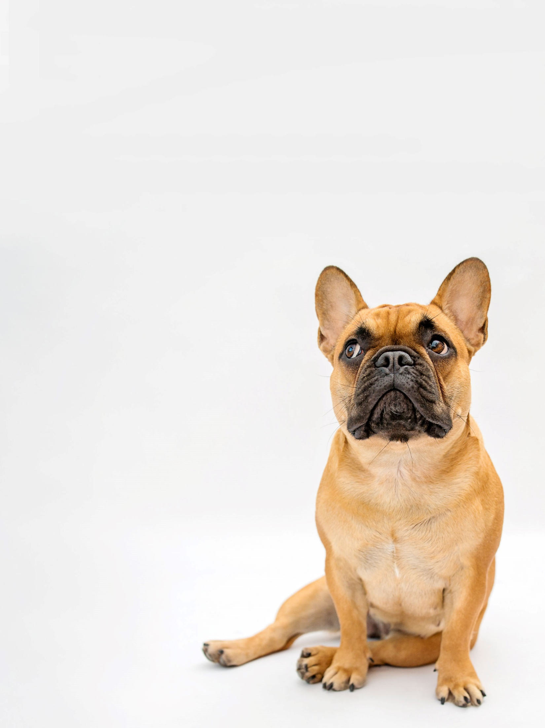
Pug and Little Paws Boarding
Keeping dogs happy and healthy
Dog Grooming

Full Groom £52
Wash & Tidy £42
Wash & Blow dry £32
Nail Clipping £10
Tidy sanitary area £20
Matted hair £20
Plaque removal (6 week course) £50
Ongoing Teeth maintenance £10
(Free for current Day & Boarding customers)

Please let us know if you wish to have any of these
services while they are boarding with us.

pugandlittlepawsboarding.uk
Phone: 07795364925
Email: calderbank7@aol.co.uk

Booking Form

Please book my dog(s) in for the following services:

Service | Dogs Name | Date
Full Groom - £52
Wash & Tidy - £42
Wash & Blow Dry - £32
Nail Clipping - £10
Tidy Sanitary Area - £20
Matted Hair - £20
Teeth Cleaning 6 week Course - £50
Teeth Maintenance - £10

Please ensure you have booked in advance of drop off and full balance to be paid by 14 days prior to drop off date. If you wish to use this service during daycare then we will require a minimum of 48hrs notice.

Cancellation Policy
Cancellation within 48hrs you will be charged full cost of service.
Cancellation between 7 days and 48hrs will be charged 50%
Full payment required at booking.

