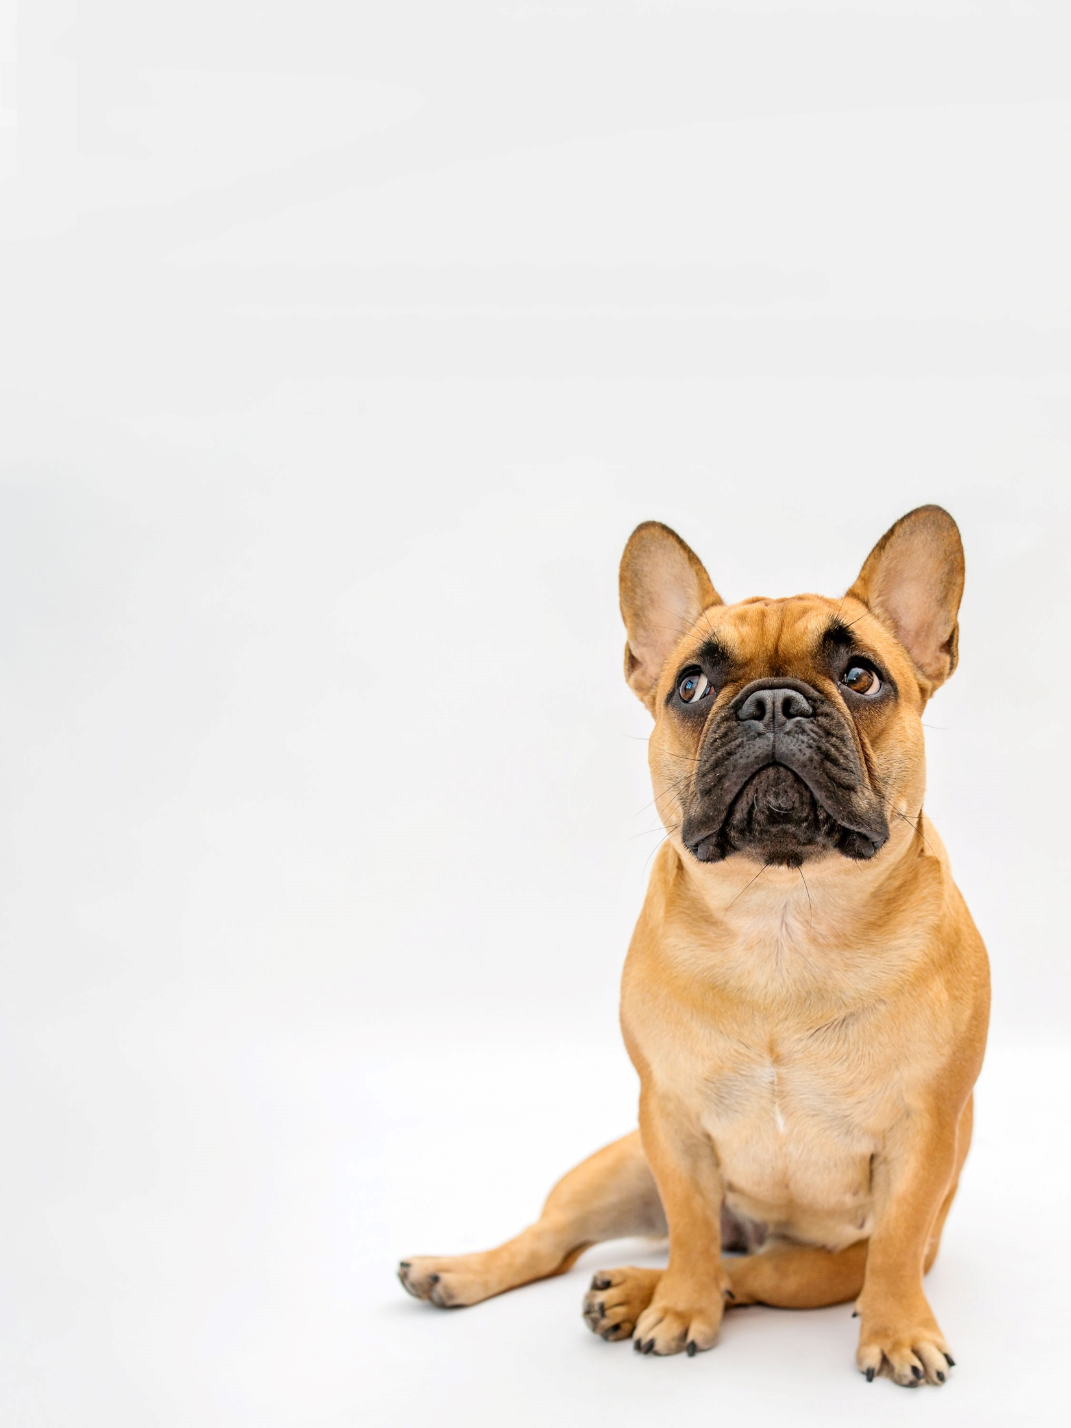

Pug and Little Paws Boarding

Keeping dogs happy and healthy

Dog Grooming

Full Groom £42

Wash & Tidy £32

Wash & Blow dry £22

Nail Clipping £10

Tidy sanitary area £12

Matted hair £12

Please let us know if you wish to have any of these

services while they are boarding with us.

pugandlittlepawsboarding.uk

Phone: 07795364925

Email: calderbank7@aol.co.uk

**Booking Form**

Please book my dog(s) in for the following services:

|  |  |  |
| --- | --- | --- |
| **Service** | **Dogs Name** | **Dogs Name** |
| Full Groom |  |  |
| Wash & Tidy |  |  |
| Wash & Blow Dry |  |  |
| Nail Clipping |  |  |
| Tidy Sanitary Area |  |  |
| Matted Hair |  |  |

Please ensure you have booked in advance of drop off and full balance to be paid by 14 days prior to drop off date. If you wish to use this service during daycare then we will require a minimum of 48hrs notice.

Cancellation Policy

Cancellation within 24hrs you will be charged full cost of service.

Cancellation between 7 days and 24hrs will be charged 50%

20% deposit required at booking (non-refundable)

Full payment required by drop off.