May 2026

Pug and Little Paws Boarding
Pricing per dog
Daycare
No daycare will be taken over the weekends Fri – Sun.
Full day: 9am – 6pm £36
Half day: max 4 hrs between 10am – 5pm £25
Full payment is due on day of booking.
(Outside of these times can be negotiated to meet your needs if required on a regular basis.)

Overnight Stays – £46 + (10am – 10am)
Weekend Stays Fri – Sun
Overnight stays -£56 +
Drop off anytime between 10am – 5pm
Plus on final day of stay:
Collection by 10am No additional charge
Collection by 12pm £20
Collection by 6pm £30
30% of total is due on day of booking and final payment 14 days prior.
Any late collection past the agreed time will be charged at an equivalent of £40 per the hour unless agreed.
Additional Services (to be paid in advance with booking fee)
Vet Visits
Within a 5-mile radius only. £10
(Outside of this area your dog will be taken to Medivet Watford, St Albans Rd.)
Un-neutered Occasionally we will allow un-neutered dogs under
Vet advice. Additional costs are incurred due to this for various
reasons including walks in secluded places. Per day £5

Puppies up to 18 months an additional cost per day. £10

Wedding Chaperone Service (tailored to your needs) POA

Grooming services
Full Groom £52
Wash & Tidy £42
Wash & Blow dry £32
Nail Clipping £10
Tidy sanitary area £20
Matted hair £20
Teeth Cleaning:
Assessment FOC
Initial Course of descaling over 6 weeks £120
Continued care (scale & Polish) £20
(recommended every 2 weeks if teeth not brushed at home)

Additional Therapies
Rehab Mobility
Initial assessment £60
Follow up sessions £40
A six session course post initial assessment £200
Rehab with red light therapy
Follow up sessions £45
A six session course post initial assessment £225

Rehab with Ultrasound therapy
Follow up sessions £50
A six session course post initial assessment £250

Top up and maintenance can be discussed POA
Total is due on day you place order.

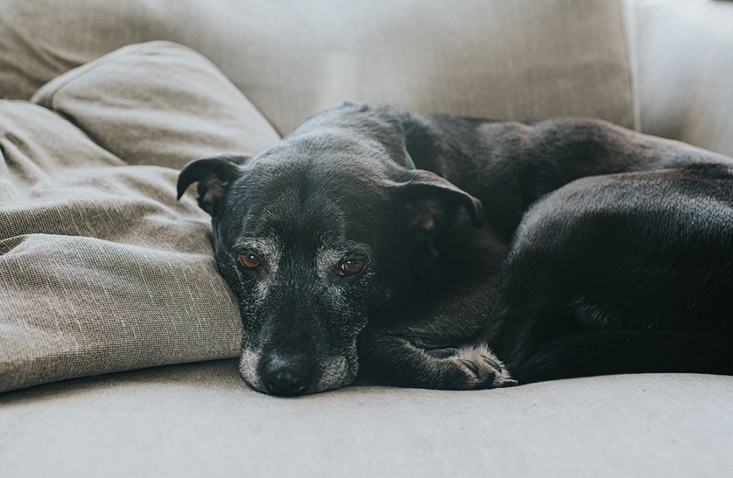

Payment Options
- Full payment required 14 days prior to drop off.
- Bank Transfer (preferred)

Name: M Calderbank
Sort Code: 05-05-40
Account No: 34234916

- Cash.

Please Note:
Additional £20 on all public holidays except for Christmas period:
Double charges from 24th Dec through to 2nd Jan inclusive. 40% due on day of booking – non refundable.

Cancellation:
Cancellation within 72hrs you will be charged full cost of stay (alternative therapies, grooming and daycare not included).
Cancellation between 14 days and 72hrs will be charged 50% (alternative therapies, grooming and daycare not included).
30% booking fee required at booking (non-refundable) except for day or half day booking which is total cost of day. These may be transferable depending on occupancy and taken within 3 months.

Contact:
Mobile: 07795364925
Email: calderbank7@aol.co.uk
Address: 7 Mutchetts Close, Watford WD25 9TS

We are fully insured by Pet Business Insurance. Fully qualified first aid for dogs with additional training for brachycephalic breeds. Enhanced DBS. Fully Licenced TRDC/AAL/2510

